KS4 – Databases and SQL Learner activity sheet

Lesson 1 – Database essentials



# Database key terms quiz

Task Complete the quiz

A database is a structured collection of data that can easily be searched and updated. Here are some questions about database key terms.

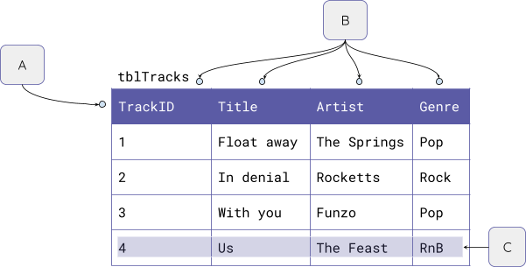

**Question 1:** Match the key term to the letters in the diagram.

|  |  |
| --- | --- |
| Key term | Letter |
| Table |  |
| Fields |  |
| Record |  |

Page 1 Last updated: 22-07-21

KS4 – Databases and SQL Learner activity sheet

Lesson 1 – Database essentials



**Question 2:** State the field name that is the **primary key**.

**Answer** 

**Question 3:** Which of these statements best describes a flat file database.

1. A database that has a single table
2. A database that has multiple tables
3. A database with a limited number of fields
4. A database that doesn’t have a primary key

**Question 4:** Select all of the properties of a **primary key**.

1. Each value held must be unique
2. The same primary key can be used for multiple entries
3. A primary key allows you to identify each unique record
4. A primary key must always be a number

Resources are updated regularly — the latest version is available at: [ncce.io/tcc](http://ncce.io/tcc).

This resource is licensed under the Open Government Licence, version 3. For more information on this licence, see [ncce.io/ogl](http://ncce.io/ogl).

Page 2 Last updated: 22-07-21